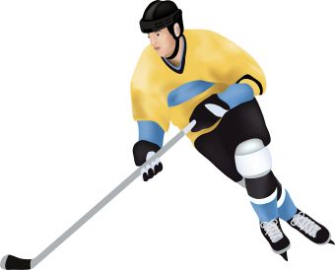**South Jersey**

**Inline Hockey**

**Is Sponsoring a Winter Roller Hockey 2022**

We are pleased to offer Inline Roller Hockey to beginner level players, 6 years old to 12 years old, who want to improve his/her basic skills and knowledge of the game of inline roller hockey. Beginner skaters are welcome. This Inline Roller Hockey will be directed by Christian Chin.

**Recreational Ball Hockey**

**Dates and Times:** **To register please call *609-625-1191***Mondays Starting November 7th  
4:30 pm to 6:00 pm

**Fee:**  Weekly Fee of $15.00  
  
**Location:** **Young’s Skating Center**  
 763 Park Road   
 Mays Landing, NJ 08330

**Emphasis:**The purpose of this is to concentrate on the basics of the sport of Inline Roller Hockey. Younger, less experienced players will benefit from the beginner level skills and drills portion.

**Features:**

* Forward and backward skating
* Crossovers
* Stopping
* Stick Handling
* Passing /Receiving
* Shooting
* Shooting for accuracy
* Positioning
* Game Situations
* Goal-tending instruction

**Equipment Needed: For everyone’s safety, the following equipment is required by all players to participate:**

* In-line Skates (rental skates provided)
* Hockey Helmet with full facial protection
* Mouth guard
* Hockey Gloves
* Stick (taped blades and butt ends)
* Elbow & Shin pads
* Running shorts, sneakers, & towel
* Water bottle & snacks

**General Notes:**

* Doors will open 30 minutes prior to designated start time.
* Camp will start promptly at designated start time.
* Bring a roll of Hockey tape.
* Pick up is no later than 30 minutes after the completion